
Language Transport (BC-CTS-LAN)


HELP.BCCTSLAN
Release 630

Copyright

© Copyright 2003 SAP AG. All rights reserved.

No part of this publication may be reproduced or transmitted in any form or for any purpose without the express permission of SAP AG. The information contained herein may be changed without prior notice.
Some software products marketed by SAP AG and its distributors contain proprietary software components of other software vendors.

Microsoft®, WINDOWS®, NT®, EXCEL®, Word®, PowerPoint® and SQL Server® are registered trademarks of Microsoft Corporation.

IBM®, DB2®, DB2 Universal Database, OS/2®, Parallel Sysplex®, MVS/ESA, AIX®, S/390®, AS/400®, OS/390®, OS/400®, iSeries, pSeries, xSeries, zSeries, z/OS, AFP, Intelligent Miner, WebSphere®, Netfinity®, Tivoli®, Informix and Informix® Dynamic ServerTM are trademarks of IBM Corporation in USA and/or other countries.

ORACLE® is a registered trademark of ORACLE Corporation.

UNIX®, X/Open®, OSF/1®, and Motif® are registered trademarks of the Open Group.

Citrix®, the Citrix logo, ICA®, Program Neighborhood®, MetaFrame®, WinFrame®, VideoFrame®, MultiWin® and other Citrix product names referenced herein are trademarks of Citrix Systems, Inc.
HTML, DHTML, XML, XHTML are trademarks or registered trademarks of W3C®, World Wide Web Consortium, Massachusetts Institute of Technology.

JAVA® is a registered trademark of Sun Microsystems, Inc.

JAVASCRIPT® is a registered trademark of Sun Microsystems, Inc., used under license for technology invented and implemented by Netscape.

MarketSet and Enterprise Buyer are jointly owned trademarks of SAP AG and Commerce One.
SAP, SAP Logo, R/2, R/3, mySAP, mySAP.com and other SAP products and services mentioned herein as well as their respective logos are trademarks or registered trademarks of SAP AG in Germany and in several other countries all over the world. All other product and service names mentioned are trademarks of their respective companies.

Icons

Icon | Meaning
 | Caution
 | Example
 | Note
 | Recommendation
 | Syntax

Typographic Conventions

Type Style | Description
Example text | Words or characters that appear on the screen. These include field names, screen titles, pushbuttons as well as menu names, paths and options.  Cross-references to other documentation.
Example text | Emphasized words or phrases in body text, titles of graphics and tables.
EXAMPLE TEXT | Names of elements in the system. These include report names, program names, transaction codes, table names, and individual key words of a programming language, when surrounded by body text, for example, SELECT and INCLUDE.
Example text | Screen output. This includes file and directory names and their paths, messages, source code, names of variables and parameters as well as names of installation, upgrade and database tools.
EXAMPLE TEXT | Keys on the keyboard, for example, function keys (such as F2) or the ENTER key.
Example text | Exact user entry. These are words or characters that you enter in the system exactly as they appear in the documentation.
<Example text> | Variable user entry. Pointed brackets indicate that you replace these words and characters with appropriate entries.

Language Transport (BC-CTS-LAN)

Purpose
This documentation tells you how to import languages into an SAP System.
This documentation is only available in English and German.

New Features in the Language Transport

New Features in SAP Web Application Server 6.20
- Extended Language Supplementation Program
As of SAP Web Application Server 6.20, the client maintenance function and the program RSREFILL have been integrated into the language supplementation program. Despite its extra functions, the language supplementation has also been made easier to use.

New Features in SAP Web Application Server 6.10
- In SAP Web Application Server 6.10, functions for importing the language content of Support Packages, and for client maintenance, have been integrated into transaction SMLT. Until now, these functions were available only by importing Support Packages.
- You can now display export processes in transaction SMLT as well.
- All language transport tools are now available in transaction SMLT by choosing Goto → Other Tools. You can start the tools from here. Until now, you had to call these tools separately.
- Other improvements have been made to make transaction SMLT easier to use.

Naming Conventions

SAP Basis and SAP Web Application Server
In Release 6.10 SAP Basis was renamed as SAP Web Application Server.
This documentation refers to Basis Release 4.6D and earlier releases as SAP Basis; Release 6.10 and later releases are known as SAP Web Application Server.

ID for SAP Web Application Server Release
In this documentation, the placeholder <Rel> stands for the number of the appropriate SAP Web Application Server Release without the decimal point, for example, 620.

General Information About Language Transports
This section contains information on the following topics:
- Lock Management [Page 12]
- Support Packages [Page 13]
- Customizing Tables [Page 14]

Lock Management
During a language import or language supplementation, the system locks all language management activities for that language, and rejects any attempts to carry them out. Other languages are not affected, so you can perform any actions on these languages at the same time as the import or supplementation.

Support Packages
As of Basis Release 3.0D, SAP delivers Support Packages to remove any errors that appear in important transactions.
Support Packages may contain language-dependent data, such as message texts, ABAP texts or screen texts. Once you have used transaction SPAM to import a Support Package, the translated texts for these objects are up-to-date for all languages in the system.
Problems can occur if you want to import another language from the language CD into a system into which Support Packages have already been imported. The language CD is created before the first Support Packages, and the objects in the Support Packages are only translated into the languages already imported into the system. This means that when you then import another language, you affect the translations of the objects in the Support Packages. Texts may be outdated or missing altogether.
For detailed information and an overview of solutions in various releases, see SAP Note 352941.
As of Basis Release 4.6C, you can import language data from Support Packages to make your languages consistent.
Proceed as follows:
...
  - Call transaction SMLT.
  - Choose Language → Special Actions → Import Support Packages.

Customizing Tables

Definition
Customizing data is data created by customers when they customize their systems.
The Customizing data in a customer client is not overwritten by a language import or an upgrade. Data is only imported into client 000. This is because Customizing data is the responsibility of the customer and cannot be overwritten by data from SAP. This also applies, without restrictions, to translations. However, customers may occasionally want to update their sample data and default settings with the latest translations from SAP.
Only copy the clients from client 000 after all the required languages have been imported into client 000.
You have the following options for updating a translation language for the Customizing settings of an existing customer client:
...
  - Using tools
  - Manual translation

Using Tools
As of Basis Release 3.1H, SAP provides the following tools for updating Customizing texts in clients other than 000:
- Report RSREFILL
The report RSREFILL compares the Customizing texts in the logon client with the SAP proposals in a reference language in client 000. If these texts are identical, their translations in the target language are copied from client 000 to the logon client. Data is inserted only; no existing data is overwritten.
For more information on RSREFILL, see the documentation on the report, and SAP Note 48047.
- Client maintenance with transaction SMLT
This function works in the same way as the report RSREFILL, but does not make a comparison with a reference language. This means that more texts can be copied from client 000 to the target client.
As with RSREFILL, Customizing data is inserted. No data is deleted or overwritten.
You call RSREFILL as a report. You start the client maintenance function in transaction SMLT by choosing Language → Special Actions → Client Maintenance.
SAP recommends that you use the language supplementation program, which now integrates the program RSREFILL and the client maintenance function.
Combining RSREFILL or the client maintenance function with the language supplementation program has the following consequences for each client-specific Customizing table:
...
  - Any previous supplementation is reset.
  - RSREFILL or the client maintenance function is executed.
  - The table is supplemented.
This avoids any problems caused by the order in which RSREFILL, the client maintenance function, and the language supplementation program run.

Manual Translation
The link between the translation environment and the Change and Transport System enables you to create translated Customizing texts in a particular system, record them in transport requests, and distribute them in the system landscape.
Translate the remaining Customizing texts in transaction SE63. Record the translations in transport requests, and then use the Transport Management System (TMS) to distribute these requests in the system landscape.

Preparing to Import a Language

Purpose
The following describes all the preparations you need to make for a successful language import.

Process Flow
...
  - You request the necessary SAP Notes [Page 17].
  - You find out which languages are delivered [Page 18].
  - You classify each language [Page 19].
  - You check whether you have the required authorizations [Page 20].

Requesting SAP Notes for the Language Transport

Procedure
Always request the following SAP Notes from SAPNet – R/3 Frontend before you start a language import. If you do not have a connection to SAPNet, use the fax request form in the software package.
The current SAP Note for the Language Transport contains additional SAP Notes for the SAP components.
Required SAP Notes
Note No. | Title | Category
482462 | Current Information on Language Import 6.20 | Information on installation
73606 | R/3 Language Combinations | Consulting
15023 | Initializing Table TCPDB | Information on installation

Recommended SAP Notes
Note No. | Title | Category
18601 | Frequently Asked Questions on Language Import | Recommendations / additional information
43853 | Consulting: Language Transport and Customizing Tables | Consulting
352941 | Consulting: Languages and Support Packages | Consulting

Delivered Languages
For information about delivered languages, see the SAP Service Marketplace at service.sap.com/languages. For specific information about mySAP.com components, choose mySAP.com Business Applications. Note that the proportion of the system that is actually translated into each of the delivered languages can differ. This depends on national requirements.
There may be multiple language deliveries in a single release. Pay attention to any official announcements about language deliveries.

Classifying a Language

Use
You must classify each language so that the system can recognize it. Otherwise you will not be able to import a language package, nor supplement the language.

Procedure
...
  - Choose Classify Language (Language symbol) or choose Language → Classify.
  - On the following dialog box, choose the language you want to import, and the corresponding supplementation language.
  - Note that the imported languages (whether imported with transaction SMLT or in an upgrade) must be defined in the instance profiles so that you can log on in these languages. The relevant parameter is zcsa/installed_languages.
SAP recommends that you supplement every language that has not been translated completely (languages other than English and German) after it has been imported successfully. This guarantees you correct texts for all texts in the system. You can check how much of a language has been translated by going to the transaction SMLT and choosing , or by choosing Language → Information.
The following rules apply when you define the supplementation logic:
- You cannot supplement a language that has a complete translation.
- You must define a supplementation language for each language in the system that does not have a complete translation.
- You can only supplement from a language with a complete translation, or from a language that itself has been supplemented from a language with a complete translation.

Displaying or Changing Information About a Language
Choose the Information pushbutton at any time to display the settings that apply to a particular language. If you did not specify a supplementation language when you classified the language, you can follow this up here at any time.

Required Authorizations

Use
Users need the following authorizations in the field CTS_LANFKT of the authorization object S_CTS_LANG to perform the corresponding activities:
Authorization | Activities
ADMI | Language transport administration; particularly for classifying additional languages
INST | Import of a language package
SUPL | Language supplementation
SHOW | Display authorization; you cannot call transaction SMLT without this authorization
All authorizations needed for language transports are in the SAP role SAP_BC_TRANSPORT_ADMINISTRATOR.
Up to and including Basis Release 4.6B, the authorization checks for transaction SMLT were linked to the authorization object S_LANG_ADM. The authorizations do not need to be adjusted in the language transport after an upgrade.

Importing a Language

Purpose
This section contains all user input and actions needed for importing a language. The most important steps during the language import from a user point of view are described here.

Process Flow
You can import a language into an SAP system in two ways:
...
  - Language import during the upgrade [Page 22]
  - Language import with transaction SMLT [Page 23]
If an action terminates for technical reasons, you can restart it. For more information on this function, see Restarting an Action [Page 25].

Language Import During the Upgrade

Process Flow
As of SAP Web Application Server Release 6.10 there is a new upgrade procedure, the System Switch Upgrade.
The new procedure installs an instance of the target release (shadow system) in parallel with the running source release system on the same database. This parallel system contains all the software of the target release and is used to integrate any Support Packages included in the upgrade, add-ons, and customer modifications into the target release.
The language data is imported into the shadow system. This data is merged with customer object data, and only then is it made available to the new runtime environment. This also applies to the corresponding language-specific tables.
As a result, the language import is a part of the upgrade procedure. At the start of the upgrade, the system asks you whether you want to import all installed languages during the upgrade.
The languages English and German are always imported in the upgrade. Any languages that you choose not to import in the upgrade must be imported afterwards with transaction SMLT.
A language import during the upgrade consists of the following phases:
- Phase LANG_SELECT
This phase analyzes the available language CDs and unpacks the language packages that can be used in the upgrade into the upgrade directory. You are asked which languages you want to update with the language packages during the upgrade.
The analysis of the language CD is logged. The file PEVALLAN.<SID> is created in the log directory of the upgrade. This file contains additional information about the packages and can help you to find out the source of any problems.
- Phase JOB_RSTLANUPG
This phase sets the SMLT control information for the language packages imported during the upgrade.
The languages are imported into the system using the same procedure as for Support Packages. For example, this is how translations are loaded into the shadow system in the phase SHADOW_IMPORT_ALL.
The fact that the language data is always imported before any Support Packages in the upgrade means that there are no sequence problems.
After the upgrade you must use transaction SMLT to supplement the imported languages.

Language Import with Transaction SMLT

Process Flow
You can use transaction SMLT to import extra language packages.
The languages English and German are complete in all newly installed systems. You do not need to import them into installed systems.
...
  - Go to the language for which you want to install extra packages and choose or choose Language → Import Package.
  - In the next dialog box, enter the path for the language packages. Choose Find Package(s) to search for any available packages in the path you have entered.
  - The green, yellow and red lights next to the packages indicate whether you can import them. Click the lights to display extra information.
A green light indicates that all import conditions have been met, a yellow light indicates that there are warnings, and a red light indicates that the package cannot be imported because checks have detected errors.
  - Select one or more language packages with green or yellow lights for import.
  - After you have specified a start time and (optional) target server, choose Execute to import the language package(s) you have selected. This action schedules a background job that performs the supplementation.
  - An import action is created for the appropriate language on the overview screen of transaction SMLT. There are various functions in the overview for managing and monitoring the import.
The overview contains the following icons:
Display transport logs
Display job information
Display action log
Restart action, if it has terminated for technical reasons
Display more information about the package
  - The icon at the start of the line indicates the status of the import.
The icons have the following meanings:
The import was completed without errors.
The import was completed, however, there are warnings. For more information about these warnings, see the transport logs.
The import was completed, however, transport errors occurred in the objects. For more information about these errors, see the transport logs.
The import is scheduled. Choose to display job information, such as the start time and target server.
The import is currently running.
The import has terminated for technical reasons. To find out the cause of the error, see the job log (choose ).
The import is active. The transport control program is running. The language transport is waiting until the language data has been imported, and will then continue.
  - If an action terminates for technical reasons, you can restart it. For more information on this function, see Restarting an Action [Page 25].
As described above, you can import multiple languages in parallel. Depending on the performance of your SAP System, a parallel import of multiple languages can place a heavier load than a sequential import.
  - After importing the languages, you must also import the language data in the Support Packages. To do this, proceed as follows:
- Start transaction SMLT.
- Select a language.
- Choose Language → Special Actions → Import Support Packages.

Restarting an Action
Sometimes an action may terminate for technical reasons.
Transaction SMLT indicates this with the icon .
Possible causes include technical problems in the transport programs (such as file system problems), or data entries not being inserted due to tablespace (Dbspace) problems.
If you encounter any of these problems, you can reschedule the action with the restart function. To do this, choose .
Always use transaction SMLT to restart an action.
When you use transaction SMLT to restart an action, you make sure that the entries in the control tables are updated.
You also make sure that the action is restarted and continued at the exact phase where it terminated.

Post-Import Actions

Purpose
The following describes the actions you need to perform after the language import.

Prerequisites
The language import was successful.

Process Flow
...
  - Check the log files [Page 27].
  - Start the language supplementation [Page 28].
  - Check the current status of the language [Page 31].

Checking Log Files

Use
When you import requests, several log files are created in the transport directory of the system. You can use transaction SMLT to view these files.

Procedure
Starten Sie die Transaktion SMLT .
Expandieren Sie bei der Sprache, für deren Importprotokolle Sie sich interessieren, den entsprechenden Teilbaum mit der Übersicht über die importierten Pakete.
  - Start transaction SMLT.
  - Go to the language whose import logs you want to view and expand its node to see the packages that have been imported.
Check the status of the action, indicated by the icon at the start of the line.
  - To display the action logs, choose . These logs contain information on the individual language import steps, including any errors.
  - To go to the overview of all requests that belong to a package, choose or double-click the name of the main transport request.
  - The logs that you display are standard transport logs.

Starting Language Supplementation

Use
Use the language supplementation function to fill in the gaps in a language that has not been translated completely.
Supplementation actions are client-specific. The languages are supplemented in the client in which you are logged on. If you use multiple clients, you must supplement the languages explicitly in each production client.
You can also access the texts stored in cross-client database tables from all clients simultaneously. The default setting specifies that cross-client tables are supplemented when you are logged on to client 000.

Procedure
  - Go to the language that you want to supplement and choose or Language → Supplement Language.
  - On the next screen, enter a description of your supplementation. This helps you to recognize the supplementation you have started in the transaction SMLT overview.
  - In the center of the dialog box, enter the conditions for selecting the tables you want to supplement. These fields are set with SAP defaults that depend on the logon client, however, you can change them.
Client-specific Customizing tables are subject to special handling during language imports. This has resulted in the following supplementation strategies being created:
- Combined with RSREFILL (standard setting when logging on to clients other than 000)
- Combined with Client Maintenance
- Supplement Only
For more information on these strategies, choose Information on Table Selection in the system, or see the section Customizing Tables [Page 14].
  - Enter a start time and (optional) target server, and then you are ready to supplement the language by choosing Execute. This action schedules a background job that performs the supplementation.
  - The overview screen of transaction SMLT creates a supplementation entry for the appropriate language. Choose the corresponding icon to administer and monitor the supplementation.
The overview contains the following icons:
Display supplementation log (in table)
Display job information
Display job log
Restart action, if it has terminated for technical reasons

  - The icon at the start of the line indicates the status of the import.
The icons have the following meanings:
The selected table was supplemented without errors.
There were warnings during the supplementation. You can analyze these warnings by displaying the supplementation log. To display the supplementation log, choose or double-click the name of the supplementation action.
There were errors during supplementation. Analyze them as described above.
The action is scheduled. Choose to display job information, such as the start time and target server.
The action is currently running.
The action has terminated for technical reasons. To find out the cause of the error, see the job log (choose ).

  - The supplementation log gives you detailed information about the tables that have been supplemented.
Each line of the log contains the name, class, description, and other information about a supplemented table. The status, client, and supplementation mode appear first, followed by statistics about how many rows in the table have been processed, inserted, and modified. You can also see a return code.
All tables that have been processed fully are given a status based on the return code. This status is indicated by a green, yellow, or red light.
For information about the meaning of the return codes, display the F1 help for the return code (RC) column.

Language Supplementation (Expert Mode)
If you want to supplement a more precise selection of tables, application tables, for example, use the expert mode of the language supplementation program.
Proceed as follows:
...
  - Choose the following for the language that you want to supplement:
Language → Special Actions → Supplementation (Expert).
  - On the next screen, enter a description of your supplementation. This helps you to recognize the supplementation you have started in the transaction SMLT overview.
  - In the center of the dialog box, you can specify conditions for selecting the tables you want to supplement. These fields are set with SAP defaults, however, you can change them by choosing Change.
The default is set so that if you are logged on to client 000, all cross-client and client-specific tables are supplemented in client 000. In other clients, only the client-specific tables in the logon client are selected for supplementation.
  - The tables that you want to supplement appear at the bottom of the screen, according to the selection you made by choosing Select. Each table is shown with its table class, a description, the supplementation mode, and the client in which the table will be supplemented. You can use the appropriate pushbuttons to change this list, however, we recommend this for experienced users only.
Read the long texts of the dialog boxes that appear when you change the defaults.
For information on the rest of the procedure, see the section Starting Language Supplementation [Page 28].

Checking the Current Status of a Language

Use
Log on to the system to check the current status of a language. If the language is not up-to-date, a dialog box appears immediately, informing you that you have logged on in a language that is not installed correctly.

Procedure
...
  - To display the status of a language, start transaction SMLT.
  - Choose or Edit → Expand.
Um den Status einer Sprache anzuzeigen, starten Sie die ...
...
...
...
An overview of all languages in your system appears, as well as all actions that have been performed for each language.

Special Actions in the Language Transport
Importing languages into a system is a standard procedure for all customers who want to use a range of languages in their SAP system, and is described in detail in the sections above.
The following information is aimed at customers and SAP partners who have special language management requirements.
Customers who use the translation environment to translate missing texts, or to customize existing texts with their own terminology, need to distribute these changes within their system landscape.
To do this, you can use the transaction SMLT_EX to group the translations of object lists (or the entire system) in a language package, which you can then import into other systems with transaction SMLT.

Generating Language Packages

Purpose
Languages are imported into the system in language packages. Each language package can contain one or more transport requests.
To make it easier to organize multiple transport requests for the language export, they are grouped in a language package. Technically, these language packages correspond to Support Packages, such as SAP R/3 Support Packages or SAP HR Support Packages.
This means that a language export also involves the creation of transport requests and their inclusion in a language package.

Process Flow
You export languages in a user dialog in transaction SMLT_EX [Page 39].

Technical Background
The language transport is based on the SAP transport program R3trans [Ext.], which means that transport requests are used to import languages from one system into another. The system records changes made to translations in transaction SE63 [Ext.] in transport requests, and flags language-specific objects as the transport object type LANG.

Transport Objects with the Type LANG
SAP systems record all changes made in the system in transport requests. There are different types of transport objects, depending on the type of change. Each transport object consists of three pieces of information:
- Program ID
- Object type
- Object name
Program ID can be R3TR, LIMU, or LANG. R3TR is a group of objects, and LIMU is a subobject of a larger object. This means, for example, that R3TR PROG RSPFPAR is the transport of the program RSPFPAR with all its information (source code, text elements, properties, ...), while LIMU REPT RSPFPAR describes the text elements of this program.
LANG indicates the transport of all language-specific parts of an object. LANG PROG RSPFPAR selects all language-specific parts of the report RSPFPAR in a chosen language; LANG REPT RFPFPAR transports all text elements in a chosen language.
Earlier versions of R3trans could also transport translations of objects. SAP Note 45548 describes this procedure, which is still valid. Transport objects with the Program ID LANG, which transport only the language parts of an object, exist since SAP Basis Release 4.6C.
The language export splits the translations into the following groups:
- Translations that can be assigned to an object with a directory entry
- Translations of texts that originate in other language-specific tables (see Text Tables)
- Translations of texts that are imported into an SAP system using a special logic (see Objects with Special Handling)

Objects with Object Directory Entry
All system objects, such as programs, function groups, and table definitions, are stored and managed in an object directory. Each system object is assigned to a package, which itself belongs to a software component.
These unique assignments make it very simple to target and export translations for a software component.

Text Tables
As well as the translations of system objects, the system also contains a large number of language-specific texts that are stored in text tables. These text tables are usually Customizing tables or system tables.
Unlike objects that have a directory entry, the content of these tables does not have a unique assignment to a package or software component.
The following steps are performed when you transport text tables:
...
  - All texts are exported in your chosen language. The relevant transport object is LANG TABU <table name>.
  - If the text table is client-specific, then texts are taken only from the client where the export was started.
  - The content of the text table is assigned to the same package as the table itself.

Objects with Special Handling
For technical reasons, you cannot transport the following objects with one of the LANG transport objects:
- Terminology
- Glossary
- Public holiday calendar
- Balance sheet structures
- Units of measurement
However, a special solution can be used to transport these objects in logical objects. The following table shows you which transport object you can use to transport the texts for these objects in your chosen language.

Object | Transport Object | Description
Terminology | R3TR TERM <ISO language> | Transport of delivered terminology. The import of this object does not delete anything in the target system; instead, it just inserts and updates database entries.
Glossary | R3TR GLOS <ISO language> | Transport of delivered glossary. The import of this object does not delete anything in the target system; instead, it just inserts and updates database entries.
Public holiday calendar | R3TR CALE <ISO language> | Transport of translations of the public holiday calendar. Only inserts and updates database entries.
Balance sheet structures | R3TR BILA <balance sheet structure (four characters)><SAP language> | Translation of a balance sheet structure
Units of measurement | LANG LTXP MEASUREMENT-UNITS | This transport object modifies the names of units of measurements in the import system.
Where:
<ISO language> is a two-character ISO language ID
<SAP language> is a single-character language ID in SAP systems.

Compressing when Filling Transport Requests (Generic)
The language export function gives you the option of compressing the objects you want to transport, to reduce the amount of administration data. Instead of writing each program to a transport request, the language export function just writes a placeholder, LANG PROG *. The information about which programs are to be exported is saved in a database table in the export system, to save space. This information is not transported in the transport request.
No information on the imported objects exists in the import system.
The option Compress when Filling Transport Requests (Generic) is activated by default. Always keep this option activated for full exports to save memory in the database, particularly in the import system.

Transaction SMLT_EX
You can use transaction SMLT_EX to create language packages.
You create language packages in four steps:
...
  - Select the objects you want to export
  - Distribute the objects in requests
  - Start the language export
  - Monitor the export process

Process Flow
You can export the language package in one of two ways:
- Language export wizard
- Complex export process

Language Export Wizard
Transaction SMLT_EX gives you a large amount of flexibility when you choose the objects you want to export. Since you often do not need to use all the functions offered by transaction SMLT_EX, it includes a wizard that takes you through documented selection screens, and helps you to avoid errors.
If you have installed the Add-On Assembly Kit (AAK) component, you see the following question:
Use Wizard to create add-ons?
You can use this option to create and export add-on-specific language packages.

You start the language export wizard by choosing Wizard (or shift and F1).
Once you have made all your entries, choose Finish. This creates and exports the transport requests, and groups them in language packages. The export runs as a background job, which can be very long-running, depending on the volume of data. The initial screen shows you the log of the running language export. You can check the status by refreshing the display.

Complex Export Process
This option in transaction SMLT_EX gives you the greatest amount of flexibility when you choose the objects you want to export and the export options. Select the complex export process if you want to configure the export specifically for your requirements, or if you want to use special options that the wizard does not offer.
You start the export process by choosing New Export Process (or shift and F11).

Selection of Objects
Choose Select Objects. On the following dialog box you can enter object types as well as software components, packages, and transport requests.
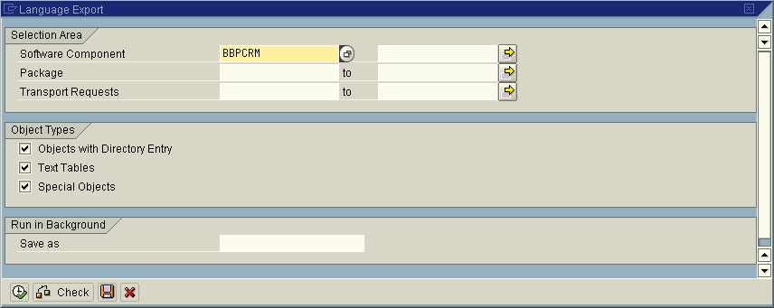
Meaning of the Selection Fields:
Selection Area
Choose objects by Software Component, Package, and/or Transport Requests.
Object Types
You can restrict the selection to Objects with Directory Entry, Text Tables, or Special Objects.
Run in Background
If you enter a name here, the objects are selected in the background and saved under this name. You see a success message once the objects have been selected.
Choose Object List → Load to load and display this or another selection.

Object Selection
The objects you want to export are displayed in a dialog box with two halves. The left side of the dialog box shows an overview of your selected objects in a structure. The right side shows the objects themselves.
The structure is ordered by Request Number, Category, and Program ID. The request number shows you which objects belong to a transport request. The objects are split into the categories Repository (objects with an object directory entry), Logical Objects (glossary, terminology, calendar, balance sheets), Customizing Tables, System Tables, and Cross-Client Tables.
The Objects column shows you the number of objects selected for each object type. It also includes totals for all categories and requests.
You have the following options on the object selection dialog box:
- Double-click a node in the structure to display all objects under this node on the right of the dialog box.
- You can delete individual objects in the context menu.
- You can use Drag&Drop to redistribute the objects among the requests.
- Choose Extras → Number of Requests to specify the number of transport requests. You can specify up to nine requests.
The number of requests affects the performance when you import languages into a system. You can import multiple requests in parallel. The more requests you specify, the quicker the import.

Saving Object Lists
Complete object selections are initially saved in the main memory, and you can view them in the object selection dialog box. You can then save these selections to the database by choosing Object List → Save. To edit these object lists again, you can reload them into the main memory by choosing Object List → Load. You can delete the object list currently in the main memory by choosing Object List → Delete.

Distributing the Objects in Requests
To save system resources and speed up the import, you can distribute large amounts of language data among multiple transport requests.
If you use the language export wizard, you can specify the number of requests for the objects.
If you use the complex export process, you can redistribute the objects among a chosen number of transport requests by choosing Extras → Number of Requests.
The complex export process also lets you use Drag&Drop to include objects in a request. Drag an object type from the tree view to a transport request. The screen is updated accordingly. If you drag an object type to the transport request New Request, then a new transport request is created for this object.

Starting the Export
Choose Start Export. You see a dialog box in which you enter further parameters, including the languages from which you want to export.

Languages
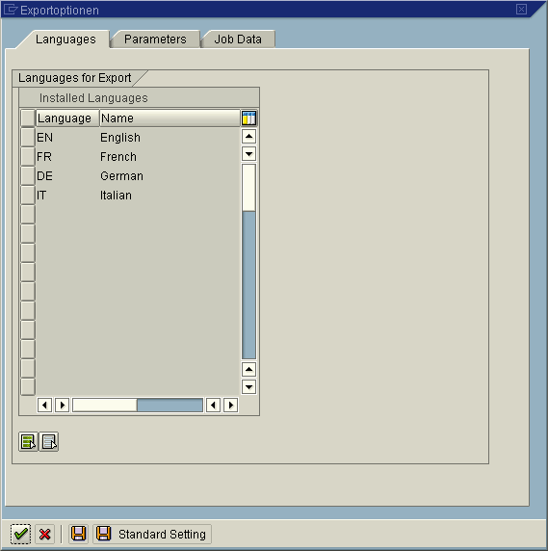
Select the languages you want to export.

Parameters
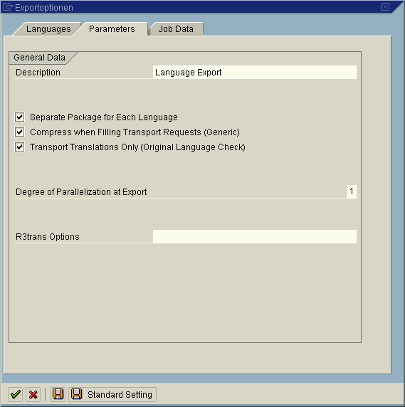
Enter further parameters for the export.
- Description
Enter a description for the language package. Enter an appropriate name (in English, if possible), such as the name of the product and a language ID. Do not use any special characters.
- Separate Package for Each Language
This option must always be activated. We recommend that you create one package for multiple languages only for a very small change, such as a single terminology change in multiple languages.
- Compress when Filling Transport Requests (Generic)
This option reduces the size of the data file, which speeds up the import.
If you activate this option, the import system no longer contains the object list. (See also Technical Background [Page 34]).
- Transport Translations Only (Original Language Check)
This prevents original language objects from being transported.
- Degree of Parallelization at Export
Number of R3trans processes at export. Set this option to correspond to the performance of your application server.
- tp options
This option allows you to specify additional parameters for the programs tp and R3trans. You can specify any of the tp options on the command line.

Job Data
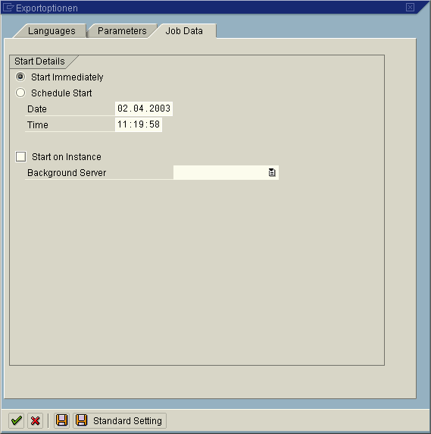
Under Start Details, specify whether you want to start the export immediately, or schedule it in the background. Start Immediately is the default setting.
You can also activate the option Start on Instance, and choose a Background Server. This is a good idea if, for example, you are running more than one export at the same time. This option is deactivated by default, and the export then runs on the fastest server.

Logs
The language export generates logs that help you to analyze any errors. By default, the initial screen of the language export function shows you all exports made in the last 30 days, together with their log information. You can select a longer interval for the export display.
To display the logs, choose the relevant icon.
- Job Log
Depending on how you start the language export, either the whole of the export, or just parts of it are performed in the background. Job logs are always created with the name SAP-LANGUAGE-EXPORT. These job logs are a subset of the language export log.
- Action Log
A language export log that contains information on your selection options, parameters, and the most important export steps. Long texts provide more detailed information on each step.
The action log is the only log that is not deleted at a later time. You can check this log at any time on the initial language export screen.
- Transport Logs
Each transport package consists of at least one transport request, which is exported by the programs tp and R3trans. The export log is located at the file system level, from where you can display it in transactions SE01, SE09, or SE10.

Troubleshooting
Sometimes, problems arise because the language export tool uses tools outside of the SAP system. This section gives you information on avoiding language export problems.
- Authorizations
To export a language, you require the authorizations in the role SAP_BC_TRANSPORT_ADMINISTRATOR.
- Transport Management System
Use the Transport Management System (transaction STMS) to check the configuration and functions of the transport tools.
- Problems with different servers
You may only be able to perform the export on a specific server, which must be configured for export languages. This means that the prerequisites for using a specific language in the SAP system must be fulfilled, in particular, the appropriate locales must exist at the operating system level. You can specify a server under Job Data in the export options of transaction SMLT_EX.
- Restarting a language export
You can restart an export that has terminated. To do this, go to the initial screen of transaction SMLT_EX and right-click the stop sign. Then choose Restart.

